LUXELANE FASHION

BUSINESS PERFORMANCE AND RECOVERY ANALYSIS

BUSINESS OVERVIEW
LUXELANE Fashion is a fictional women’s fashion and accessories business offering products across categories including dresses, bags, tops, trousers and accessories.
The business experienced a noticeable decline in performance during the second half of 2025. This analysis was conducted to understand what was driving the decline and identify opportunities to improve revenue, profitability and customer experience.
PROJECT OBJECTIVE
1. Project Objective:
I analysed LUXELANE Fashion's 2025 sales and customer data to identify the factors contributing to the decline in H2 performance and provide data-driven recommendations for improving revenue, profitability and customer experience.
2. Data
Dataset size: 1,500 orders
- Source: chatgpt
- Period: January–December 2025
- Tools: Microsoft Excel and power query
- Key variables analysed: revenue, profit, discounts, products, acquisition channels, delivery time, complaints, returns and customer behavior.
- Techniques: data cleaning, aggregation, H1 vs H2 comparison, trend analysis and KPI analysis.
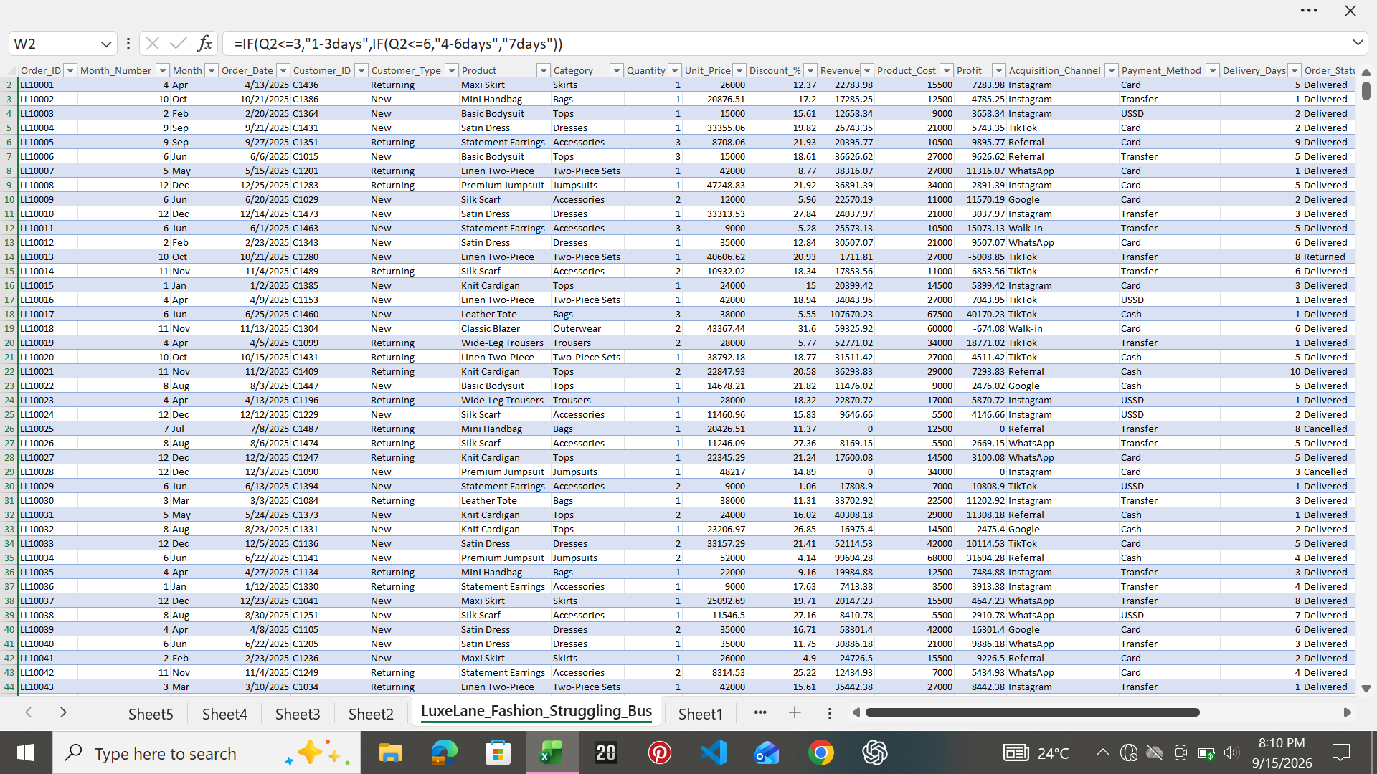
3. Dashboard: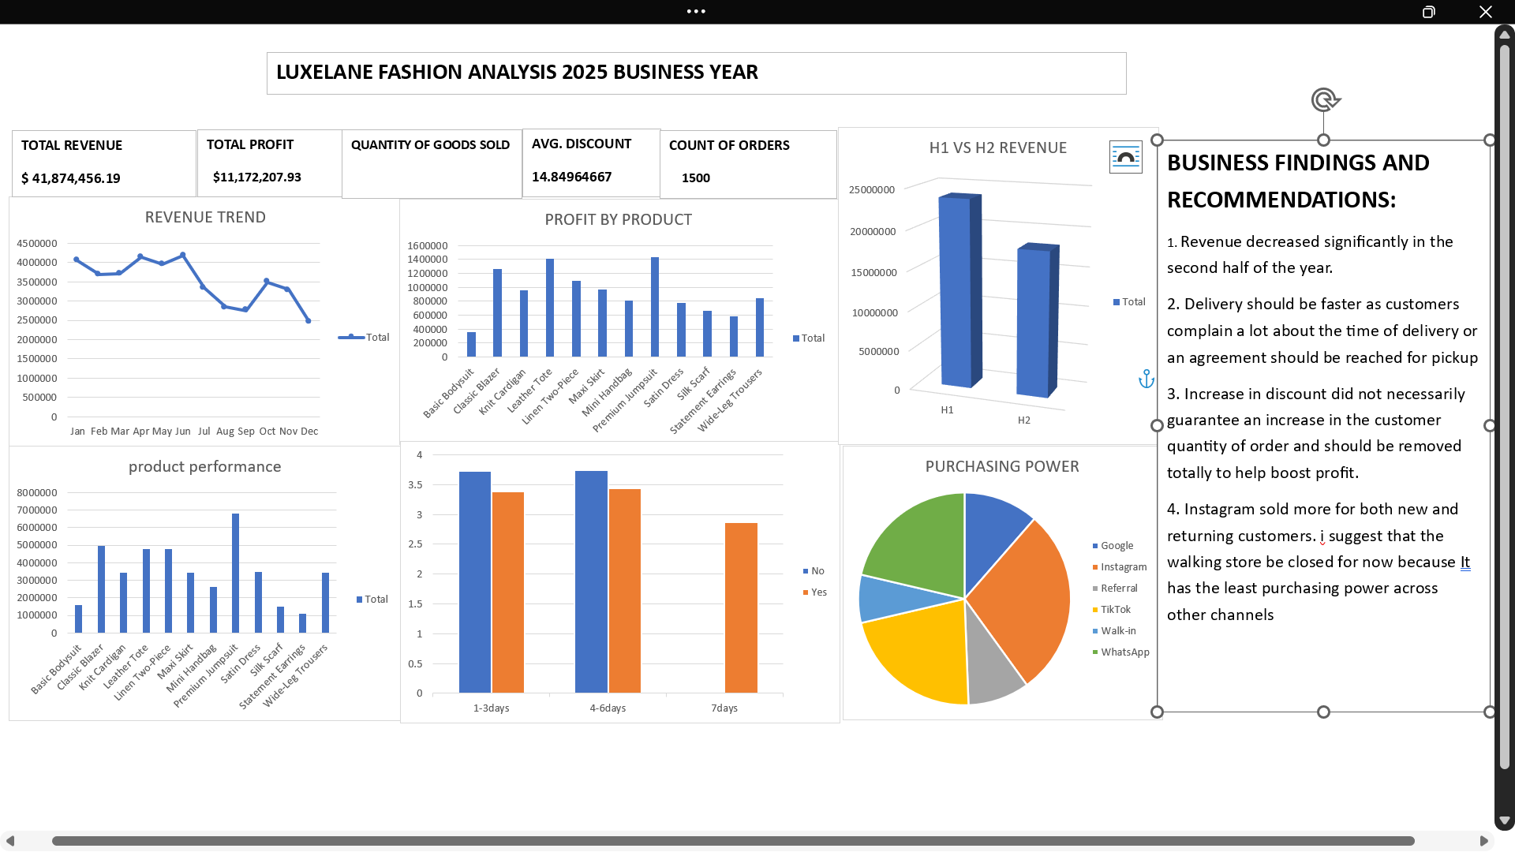
4. Limitations / Next Step:. This analysis identifies relationships within the available sales data but does not establish causation. Further analysis using customer-level retention data, marketing spend, inventory information and delivery-partner data would help LUXELANE determine the financial impact of these factors more precisely.

BUSINESS PROBLEM
LUXELANE generated approximately ₦41.87M in revenue and ₦11.17M in profit during 2025. However, performance weakened significantly in the second half of the year.
Metric | H1 | H2 | Change
Revenue | ₦23.72M | ₦18.16M | ↓ 23.4%
Profit | ₦7.49M | ₦3.68M | ↓ 50.8%
Average Discount | 10.8% | 18.9% | ↑ 75%
Average Delivery Time | 2.8 days | 4.6 days | ↑ 64%
This raised the key business question:
Why did LUXELANE become significantly less profitable in H2?

WHAT THE ANALYSIS REVEALED
1. Revenue declined significantly in H2
The monthly revenue trend shows relatively stronger performance during the first half of the year, with June recording one of the strongest months. However, revenue began declining from July and reached its lowest point in December. This indicates that LUXELANE wasn't dealing with one isolated bad month. The decline became a consistent H2 pattern.
BUSINESS INSIGHT:
LUXELANE needs to investigate what changed around the middle of the year rather than simply trying to generate more sales.

2. Profit declined much faster than revenue
This was one of the most important findings.
Revenue declined by approximately 23.4%, while profit declined by approximately 50.8%.
This means the problem wasn't simply:
"We're selling less."
The business was also experiencing a profitability problem.
One major factor was discounting. Average discounts increased from approximately 10.8% in H1 to 18.9% in H2.
At the same time, average delivery time increased from approximately 2.8 days to 4.6 days.
Business insight:
LUXELANE was generating less revenue while giving away a significantly larger portion of that revenue through discounts. At the same time, its operational performance weakened.

3. Product performance was uneven
The product analysis showed that products contributed differently to LUXELANE'S performance.
Premium Jumpsuit generated the highest revenue at approximately ₦6.79M, making it an important revenue driver.
However, revenue alone doesn't tell the full story.
Leather Tote, for example, generated approximately ₦4.76M in revenue but ₦1.41M in profit, making it one of the stronger products from a profitability perspective.
This demonstrates why LUXELANE shouldn't evaluate products based solely on revenue or sales volume.
Business insight:
Product decisions should consider both revenue and profit contribution so that the business can identify products that are genuinely valuable to its bottom line.

4. Customer acquisition channels tell a different story
Instagram generated the highest revenue among the acquisition channels, at approximately ₦11.98M, followed by TikTok and WhatsApp.
However, revenue alone isn't enough to determine whether an acquisition channel is truly valuable.
LUXELANE should also evaluate:
- Profit generated
- Repeat purchases
- Customer retention
- Average order value
This is important because acquiring a large number of customers is less valuable if those customers don't return.
Business insight:
Marketing performance should be measured by customer value and profitability, not simply the number of customers acquired.

5. Customer experience may be contributing to the problem
Approximately 18.7% of orders were associated with a complaint, while approximately 5.4% were returned.
Delivery performance also deteriorated during H2, with average delivery time increasing from approximately 2.8 days to 4.6 days.
The analysis of delivery and complaints shows that complaints occurred across the delivery-time groups. Therefore, complaint volume alone shouldn't be used to conclude that a particular delivery period is responsible for dissatisfaction. Complaint rate and customer ratings should be monitored alongside delivery time.
Business insight:
LUXELANE should investigate whether operational issues such as delivery delays, product expectations and service problems are affecting customer satisfaction and repeat purchases.

ROOT CAUSE
Based on the analysis, LUXELANE'S decline appears to be the result of several issues occurring simultaneously, rather than one isolated problem. The major issues identified were:
1. Declining revenue
Sales weakened considerably during H2.
2. Increasing discounts
Average discount increased substantially, putting pressure on margins.
3. Uneven product profitability
Some products generated strong revenue but were not necessarily the strongest profit contributors.
4. Customer experience issues
Complaints and returns indicate that some customers experienced problems with their orders and that’s the reason for decline in sales in H2
5. Delivery deterioration
Average delivery time increased significantly during H2.
Recommendations
FINAL BUSINESS 1. Review the discount strategy
Instead of applying broad discounts across products, LUXELANE should identify the products and customer segments where discounts actually generate enough additional sales to justify the reduction in margin. Reduce discounts or remove entirely because its not making customers buy more
Recommendation: Track profit after discount, not revenue alone.
2. Focus marketing on profitable products
Products with strong profit contribution should receive greater attention in marketing campaigns. LUXELANE should avoid assuming that its best-selling product is automatically its most valuable product.

3. Investigate delivery problems
Management should investigate why delivery times increased during H2.
Areas to review include:
- Delivery partners
- Order processing time
- Inventory availability
- Geographic coverage
- Peak-period capacity
4. Reduce avoidable returns and complaints
Products with unusually high return or complaint rates should be investigated.
LUXELANE could review:
- Product descriptions
- Size information
- Product quality
- Product photos
- Customer expectations
5. Measure customer retention
The business should track customers beyond their first purchase.
Important KPIs include:
- Repeat purchase rate
- Customer lifetime value
- Average order value
- Revenue per customer
- Repeat purchases by acquisition channel
6. Temporarily shutdown walk-in store and operate from factory or home so the business is strictly online to reduce cost of rent and increase net profit.

CONCLUSION
LUXELANE'S 2025 performance shows that the business doesn't have a simple sales problem. It has a broader profitability and operational problem.
Revenue declined by approximately 23% in H2, while profit declined by approximately 51%. During the same period, discounts increased considerably and delivery performance weakened.
The biggest opportunity is therefore not simply to "get more customers."
LUXELANE needs to:
Protect its margins → focus on profitable products → improve delivery and customer experience → increase repeat purchases.
By addressing these areas, LUXELANE can work toward growing revenue without sacrificing profitability to achieve it.

